Health and Safety Plan
Kansas Nitrate ROAR Soil Sampling
Jackson County, KS



Prepared by
U.S. Environmental Protection Agency
Region 7
Lenexa, Kansas

November, 2023

Table of Contents
Cover Page 1
Site Information: Roles and Responsibilities 2
HASP Elements 3
Attachment A: Figures i
Figure 1 - Site Location ii
Figure 2 - Hospital Directions and Route Maps Error! Bookmark not defined.
Figure 3 – Directions from Site to Nearest Hospital iii
Attachment B: Other Site-Specific HASPs iv
Attachment C: Job Safety Analysis v
Attachment D: Sign-in Sheet – Daily Safety Meeting for EPA Personnel vi
Attachment E: Amendments vii
Amendment #1 (if needed) viii

Cover Page

Site Name: | Kansas Nitrate ROAR
Activity or Phase: | Soil Sampling
Site Location: | Jackson County, KS

This Health and Safety Plan (HASP) EPA personnel for collection of soil core samples. All EPA personnel should have completed Field Safety training and be covered under a JSA.

All EPA employees under this HASP acknowledge that they comply with any applicable requirements under 29 CFR 1910.120 (HAZWOPER), 29 CFR 1910 Subpart I (Personal Protective Equipment [PPE]) and 29 CFR 1910 Subpart Z (Toxic and Hazardous Substances).

As required by paragraph (b) of HAZWOPER, EPA has a written health and safety program that covers all field work performed under CERCLA. The program includes this HASP by incorporation, other health and safety programs (e.g., PPE, respiratory protection, medical surveillance, site control, and spill containment), an organizational structure, and a comprehensive workplan. Any aspects of the other health and safety programs, the organizational structure, or the comprehensive workplan that are refined at the site level are captured in this HASP.

This HASP will be kept on site per paragraph (b)(4)(i) of HAZWOPER and addresses all of the elements required in paragraph (b)(4)(ii)(A-J) of HAZWOPER:

- Safety and health risk or hazard analysis
- Employee training assignments
- Personal protective equipment (PPE)
- Medical surveillance requirements
- Air monitoring, personnel monitoring, and environmental sampling
- Site control measures
- Decontamination procedures
- Emergency response
- Confined space entry procedures

Site Information: Roles and Responsibilities

Site Name: | KS Nitrate ROAR Jackson County KS
Activity or Phase: | Soil core sampling
Site Roles/Responsibilities
Role/Responsibility: |  | Employer: | Name: | Title:
Oversight/Field Activities |  | EPA
Site Description:
8 agricultural fields on 3 properties. All fields are production grain agriculture, none with a current cash crop growing.
Scope of Work:
This HASP addresses on-site activities performed by OSCs, RPMs, and other EPA employees including, but not limited to the following: site visits, inspections, community involvement activities, enforcement oversight, contractor oversight, environmental sampling, and other miscellaneous field work.

For descriptions of specific tasks, refer to attached EPA JSA’s.

Site Maps:
Refer to figures in Attachment A.

HASP Elements

A. Safety and Health Risk or Hazard Analysis:
Refer to attached EPA JSA’s.

B. Employee Training Assignments:
All EPA field employees must complete 24-hour H&S training.

Refer to attached EPA JSA’s for additional task specific training requirements.

C. Personal Protective Equipment (PPE):
In general, EPA employees will wear Level D PPE when working on-site. EPA employees will wear PPE provided and/or approved by Region 7 SHEMP office, as needed.

Refer to attached EPA JSA’s for task specific PPE requirements.

D. Medical Surveillance Requirements
Medical Monitoring Requirements: OSCs, RPMs and other EPA employees must be in a Medical Surveillance Program in accordance with 29 CFR 1910 and 29 CFR 1926. A medical examination must have been completed within a 12- month period prior to on-site activity and then every three years.

Episodic Examinations: Following any accidental or suspected uncontrolled exposure to site contaminants, employees should be scheduled for a special medical examination. In the event of such suspected exposure, an injury report must be completed and sent to the SHEMP Manager (or another designated person) within 24 hours. For additional information see the Medical Surveillance Program chapter for medical surveillance requirements. Documentation of EPA training can be found on-line on the EPA Field Readiness Module.

E. Air monitoring, Personnel Monitoring, and Environmental Sampling
Refer to attached EPA JSA’s.

F. Site Control Measures
Refer to attached EPA JSA’s.

G. Decontamination Procedure
Refer to attached EPA JSA’s.

H. Emergency Response
Emergency Planning and Response Procedures:
In the event of an emergency that necessitates evacuation of a work area or the site, the following procedures will take place:

- The EPA Employee will contact all nearby personnel using the on-site communications to advise the personnel of the emergency.
- The personnel will proceed to a safe distance upwind from the hazard source.
- The personnel will remain in that area until an authorized individual provides further instructions.

Accident Reporting and Investigation:
Accidents involving injuries requiring professional medical attention must be reported within one hour of occurrence to the Safety Officer.

First aid cases not involving professional medical attention must be reported within 24 hours after occurrence.

Incidents involving property damage must be reported within 24 hours of occurrence.

After hours illnesses must be reported within 24 hours (i.e. flu, rashes)
(See the Injury, Illness, and Exposure Reporting chapter)
Procedures for Response Evaluation and Follow-up:
Notify appropriate SEMD manager(s). Consult with Region 7 SHEMP manager after incident.
Emergency Contact Information
Employer: | Contact Name: | Telephone: | Email:
Region 7 SHEMP | Roy Krueger | (913) 551-7296
Radiation Safety Officer | Chuck Hooper | (913) 551-7271
OSC/RPM:

Hospital Location and Route:
Holton Community Hospital
1110 Columbine Dr, Holton KS 66436

For hospital location and route, refer to figures in Attachment A.

I. Permit-Required Confined Space (PRCS) Entry Procedures
No confined spaces are expected, and no confined space entry at this site.

J. Health and Safety Training
All EPA field employees must complete the following training before being allowed on-site:

24-hour H&S training-hour H&S Annual Refresher, if needed
First aid (29 CFR 1910.120) and CPR training

Refer to attached EPA JSA’s for additional task specific training requirements.

Daily Health and Safety Meeting
All EPA employees must attend a safety briefing and sign the attendance sheet before beginning work for the day.

Attachment A: Figures

List of Figures
Site Name

Number | Title
Figure 1 | Site Location
Figure 2 | Hospital Directions and Route Map
Figure 3 | Directions from Site to Nearest Hospital

Figure 1 - Site Location
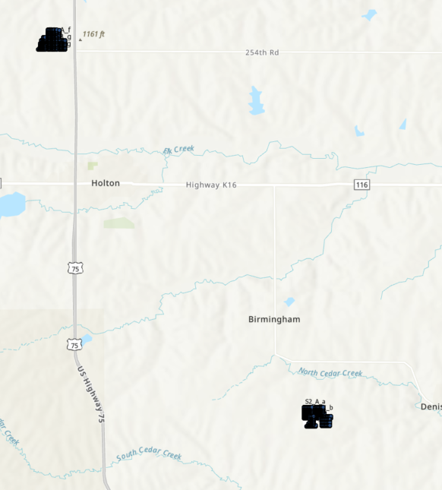

Figure 2 – Directions from Site to Nearest Hospital

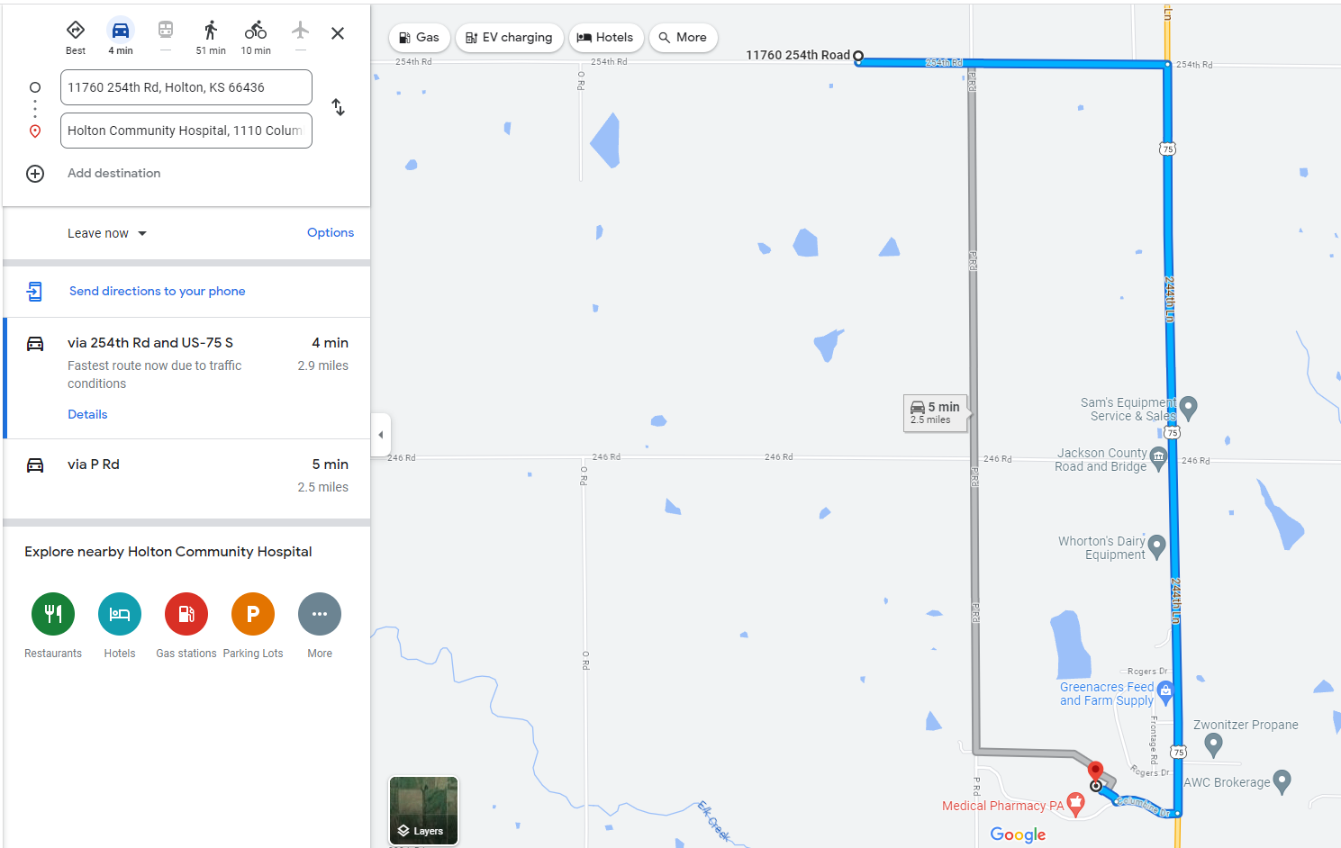

Attachment B: Other Site-Specific HASPs

List of Site-Specific HASPs
Site Name

Title | Author Affiliation  (Company or Agency) | EPA Contractor, Federal Facility, State Agency, or Other | Date

Attachment C: Job Safety Analysis

List of JSA’s
Site Name

Job/Activity Name | JSA #: | Area/Location | Date

Attachment D: Sign-in Sheet – Daily Safety Meeting for EPA Personnel

Daily Safety Meeting for EPA Personnel
Site Name

Time and Date: | Led By: | Topics Discussed:

By signing below, I acknowledge that I have read and understand the contents of this HASP.

Print Name | Division/  Branch | Signature | Date | Time

Attachment E: Amendments

HASP Amendments
Site Name

Amendment # | Name | Signature | Date

Amendment #1 (if needed)

Amendment to Health and Safety Plan
Site Name

Date: | Prepared By: | Element(s) Amended:

Insert Element Amended
Insert amendment

